VisualVid Installation
Table of Contents:
- Minimum System Requirements
- Recommended System Requirements
- Project Files
- Server Installation
- Configuring Your VisualVid Website
- Supported Codecs
- Adding .flv MIME type in IIS
- Known Issues

I. Minimum System Requirements:
Windows 2000 Server
Internet Information Services 5.1
ASP .NET 2.0
Microsoft SQL Server 2000 w/ SP4
SMTP Server (Strongly Required)

II. Recommended System Requirements:
Windows Server 2003 R2 or higher
Internet Information Services 6.0 or higher
ASP .NET 2.0 or higher
Microsoft SQL Server 2000 w/ SP4 or higher
SMTP Server

III. Project Files:
- db.zip – database files.
- www.zip – Web site files and video encoder
- VisualVid Installation.doc – this file.

IV. Server Installation:
- Designate an installation folder for the project, example: c:\inetpub\wwwroot\projects\VisualVid.
- Extract the database and website files under the project folder. Each archive should have its own folder, namely “db” and “www”.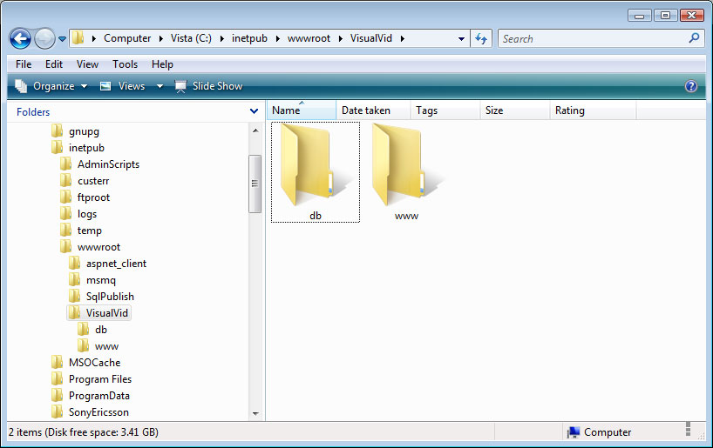
Figure 1
- Attach the database files to your Microsoft SQL Server using the Enterprise Manager. Note the username and password because this will be used for configuring the database connection of the website.
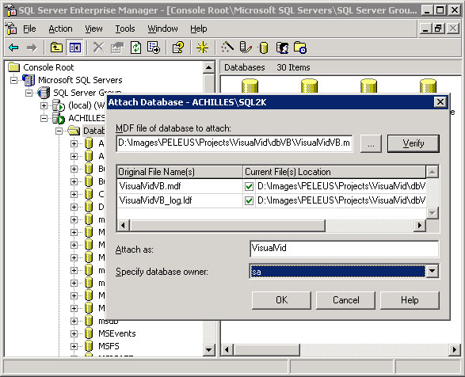
Figure 2
- Open the Internet Information Services (IIS) Manager and create a new website mapped at the physical path of the website, example “c:\inetpub\wwwroot\projects\VisualVid\www”.
- Allow the “Read”, “Write”, “Modify” and “Read & Execute” permissions to your website to the NETWORK SERVICE user (ASP.NET for Windows 2000 Server). If you’re using IIS 5.1 or IIS 6, under the ASP .NET tab, make sure the selected ASP .NET version is 2.0.xxxx. 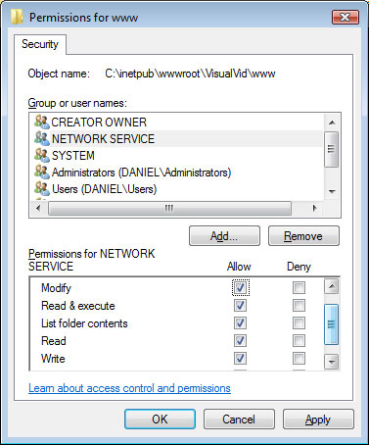
Figure 3
- If your server uses different versions of ASP .NET (1.1, 2.0), create a separate Application Pool for the website to prevent conflict. 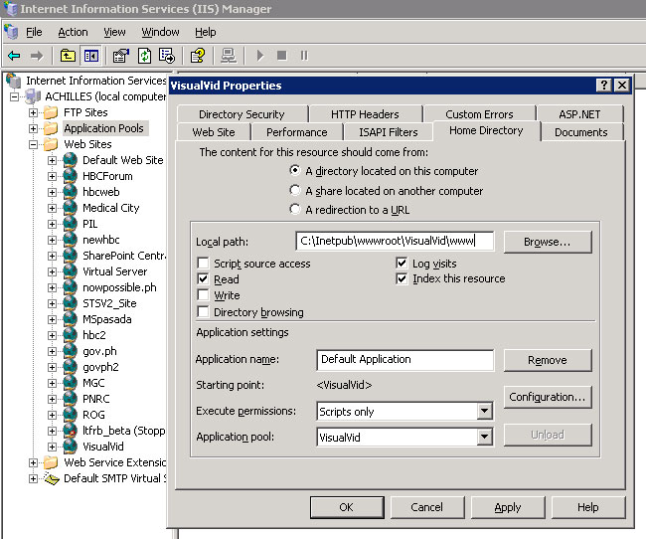
Figure 4

V. Configuring Your VisualVid Website:
- web.config
  - Under the website folder (example: c:\inetpub\wwwroot\VisualVid\www), locate the XML file web.config and open it in any text editor program.
  - Locate the node configuration\appSettings:
    - System.WebName – name of your website
    - System.MaxVideoSize – maximum video upload size. Each unit corresponds to 1 MB.
    - Email_Reg_Body – Registration email message.
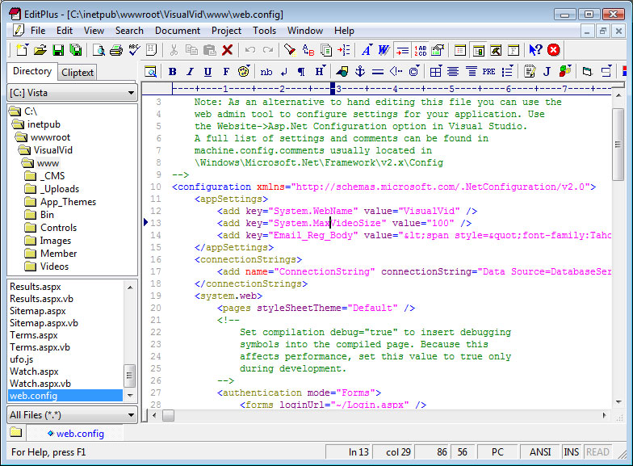
Figure 5
  - To configure the database connection string, locate the node configuration\appSettings, change the value of the connectionString key.
    - Data Source=database server
    - Initial Catalog=database name
    - User ID=database username
    - Password=database password
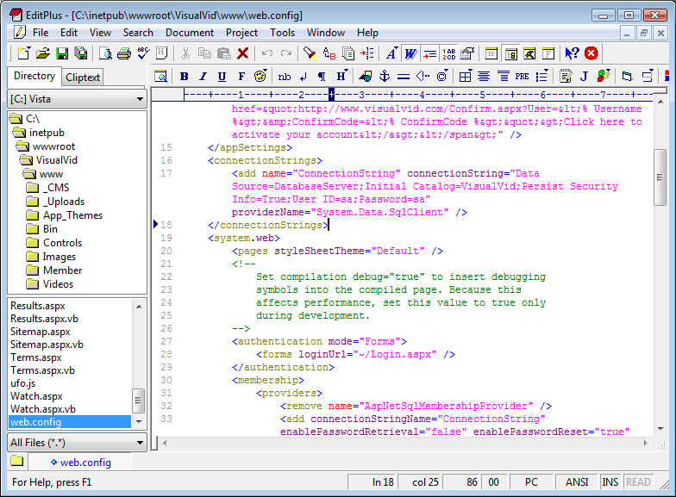
Figure 6
  - To configure the SMTP Server, locate the node configuration\sytem.net\mailSettings
    - from=the default email that will appear as sender in every email the website sent.
    - host=SMTP Serv er
    - userName and password=if the server requires authentication, unless leave it the values blank.
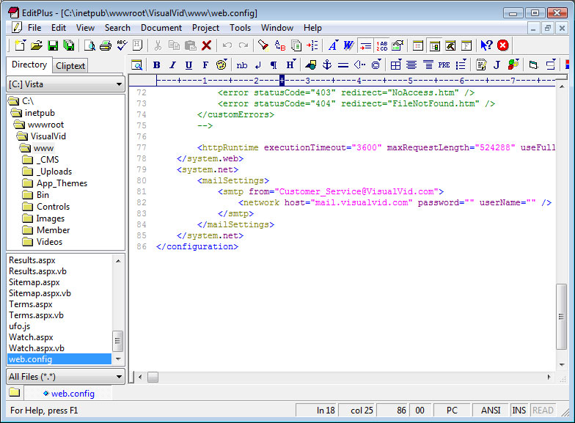
Figure 7
- VisualVid.exe.config
- Under the website folder (example: c:\inetpub\wwwroot\VisualVid\www\Videos\bin), locate the XML file VisualVid.exe.config and open it in any text editor program.
- Locate the node configuration\appSettings:
    - Email_Subject – email subject for encoded videos
    - Email_Subject_Failed – email subject for videos not supported
    - Email_Video_Link – link for newly encoded video files. Change only the domain name if necessary.
    - Email_Body – Content of the email message sent to members when their video encoded successfully.
    - Email_Body_Failed – Email message for videos failed to encode.
    - VisualVid_Home – homepage URL of the website.
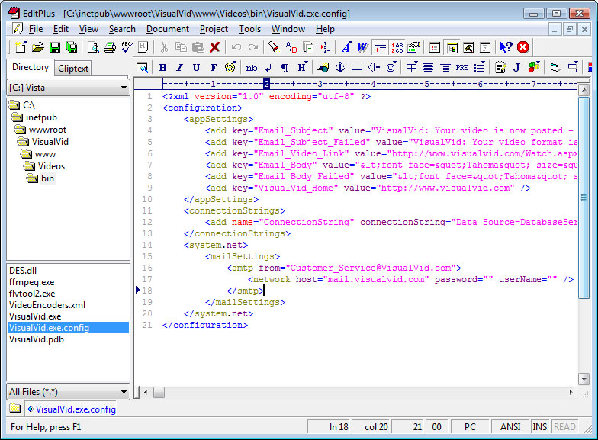
Figure 8
- To configure the database connection string, locate the node configuration\appSettings, change the value of the connectionString key. [ see Figure 6 ]
    - Data Source=database server
    - Initial Catalog=database name
    - User ID=database username
    - Password=database password
- To configure the SMTP Server, locate the node configuration\sytem.net\mailSettings. [ see Figure 7 ]
    - from=the default email that will appear as sender in every email the website sent.
    - host=SMTP Server
    - userName and password=provide these fields if the server requires authentication, unless leave the values blank.

VI. Supported Codecs
AVI
- Cinepak Codec by Radius, Cinepak by Supermac
- Intel Indeo(R) Video R3.2
- Microsoft Video 1
- Microsoft RLE
- XviD
- DivX 3 Lower Motion, DivX 4, DivX 5
- TechSmith Screen Capture Codec (TSCC)
MPEG
- MPEG-1 (VCD)
- MPEG-2 (SVCD.DVD)
- MPEG-4 (XviD, MP4, 3GPP)
Quicktime
- Sorenson Video 3 Pro with the audio codec MP3, IMA 4:1 (nicht QDesign Standard und Qualcomm PureVoice) or wihtout audio
- Exported from Quicktime Pro
- Not supported: Exported from Adobe Premiere
- Not supported: QDM2 Audio Codec
Windows Media Video
- WMV 7, WMV 8
- MPEG-4 V3
- ISO MPEG-4 V1
- Not supported: WMV 9

VII. Adding .flv MIME type in IIS
If .flv files are not registered to the web server, follow these steps:
- Select the site to configure in IIS, right click and select "Properties"
- Under HTTP Headers Tab, select "File Types" under the MIME Map section and select "New Type"
- Type ".flv" as the associated extension and "video/x-flv" as the content type.
- Select "OK" and you're ready to fly!

VIII. Known Issues
Search button focus
Issue:
When the user presses the enter key in any form in the website (e.g. Login Form), the search button always receives the command and the user is redirected to the search results page.
Solution:
Always click/trigger the designated button of the form, for example, click the Sign-In button when using the Login form instead of pressing enter after typing the username and password.
Unsupported Video Format
Issue:
When the user uploads an unsupported video format, the system will still accept the video and proceeds to the encoding process and emails the user thereafter. The video will still be posted to the website but displays a blank video / will not play.
Solution:
Do not upload unsupported video files.

